Payments
Website Landing Page
Davis & Elkins College

Website

Communication: | PayMyTuition instruction page for school website.
Purpose: | Introduce international students to the PayMyTuition payment portal as the preferred payment method for international students.

PayMyTuition
Davis and Elkins College has partnered with PayMyTuition for international tuition payments. With PayMyTuition, you can pay your tuition payments from any bank, in any country in any currency at better than bank exchange rates. PayMyTuition is fast, simple, and cost effective.
If you are an international student, you can pay your tuition and fees from any bank, in any country, in any currency at a better rate than bank exchange rates. International payment options include:
Payment method | Estimated time for payment confirmation
Bank transfers | 2-10 business days**
Debit and Credit cards in your home currency | 2-3 business days
eWallet payments | 2-3 business days
Plus, other local options (if available) | 2-3 business days
**Anticipated timelines vary depending on the country.

Preferred Payment Method for International Students
Portal Login:
Log into your Self-Service Portal:
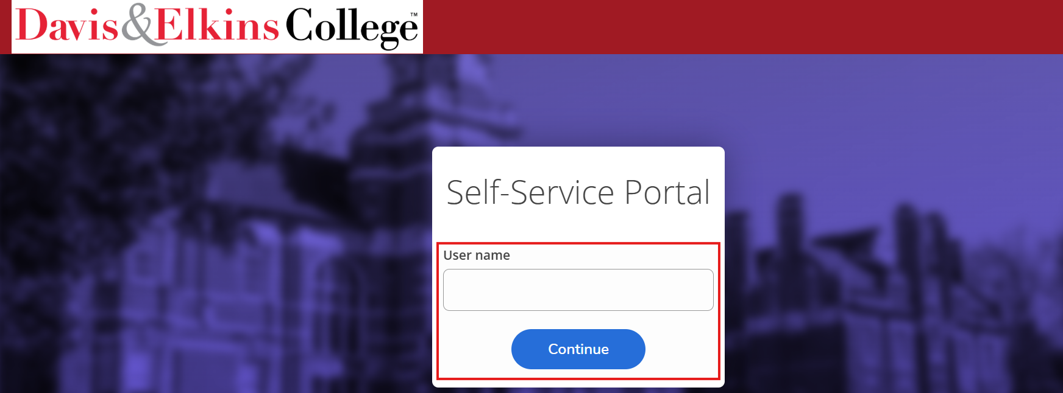
Navigation:
In the left navigation panel, select ‘Student Finance’ and click on ‘PayMyTuition (International Payments):
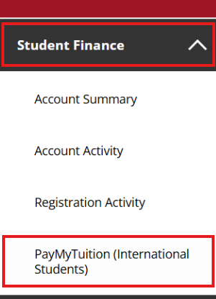

Select the PayMyTuition banner to be redirected to the PayMyTuition portal:
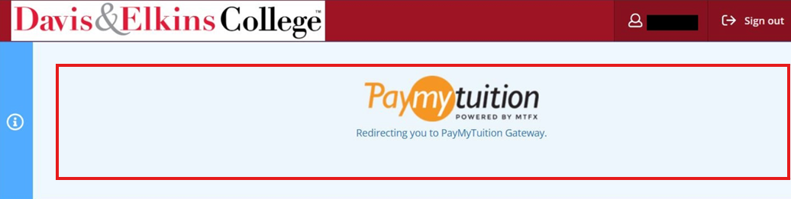
Redirect:
Upon redirecting, select the “Make a Payment” button in the PayMyTuition portal to initiate your transaction:
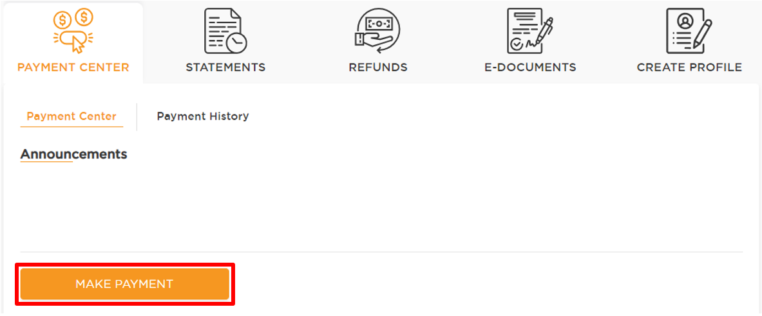
Step-by-step payment instructions (translated PDFs)
To support you with using PayMyTuition, you can download these helpful step-by-step PDF instructions, translated into 16 languages:
English
French
Spanish
Portuguese
Vietnamese
Japanese
Korean
Simplified Chinese
Punjabi
Hindi
Turkish
German
Swedish
Dutch
Additional Information on PayMyTuition:
Frequently Asked Questions
PayMyTuition’s Rate Guarantee for International Payers

Need Assistance?
Connect with PayMyTuition directly by calling 1.855.663.6839 (toll-free) or through one of their local country contact numbers.

You can also reach PayMyTuition Support at support@paymytuition.com or through their support page.

No matter what time zone you are in, you will have a dedicated customer support team available to you through live chat, email, and phone to answer any of your questions and help you with the payment process.

